**2.4 ATTACHMENT TRAINING WEEKLY SUMMARY**

*WEEK 1 summary*

In this weekly report it contains all the work done from Monday to Friday of my first week of training attachment.

The following includes all the experience gained on week one and work done.

* Opening of optical closure
* Arrangement of cores and tubes in a closure
* How to use optical tools like the fiber optic splicer, strippers, cleavers, swap (see in the next page figure 1.2)
* How to manage the tools.
* We also did software installation i.e. antivirus installation.
* I also learned how to crimp an Rj45 using a crimping tool.
* I also learned how to measure power using a patch cord and power meter as shown below.

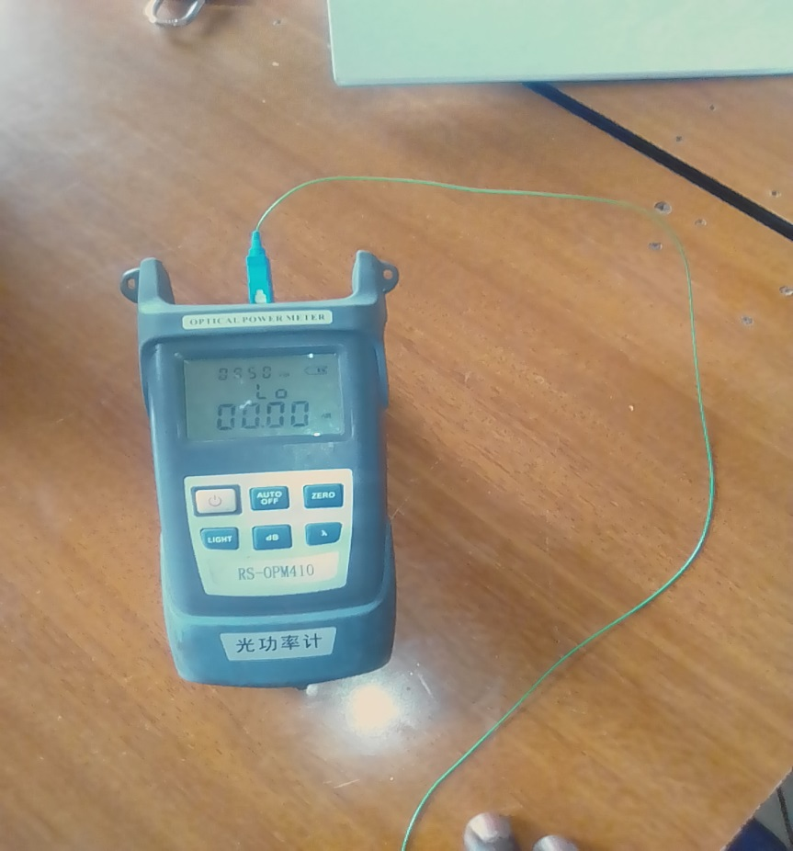

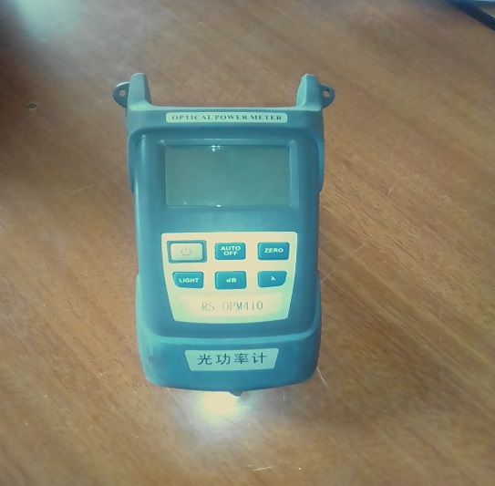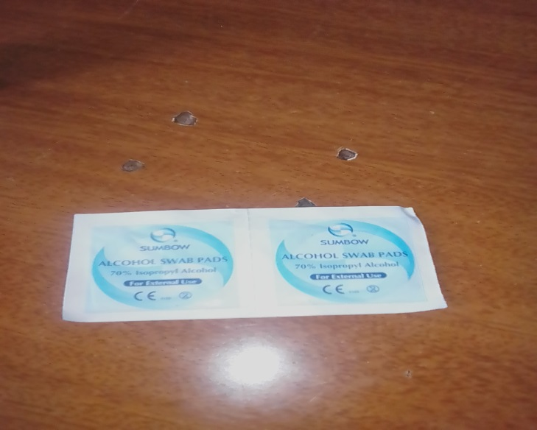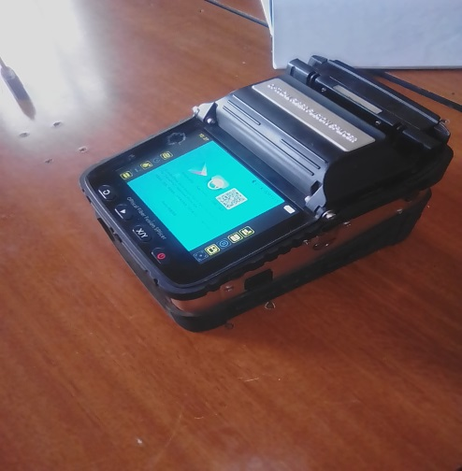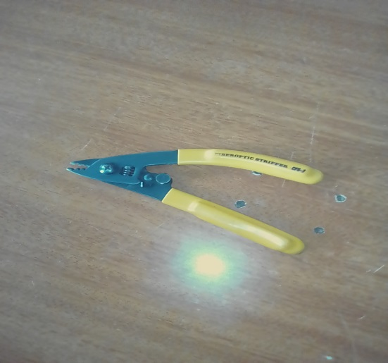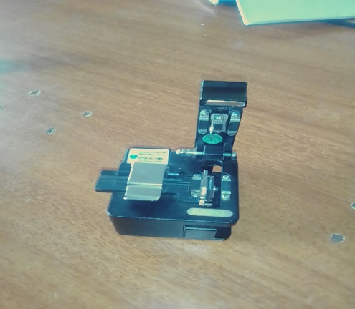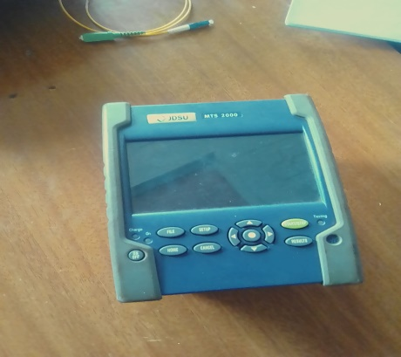

*Figure 1.2 fiber optic tools*

**Weekly2***summary*

This being the second week, I started to cope up with networking. The following includes work done and experience gained on week.

1. I learned how to run drop cables which and how to manage them from pole to pole.
2. I also got to know how to splice using the splicing machine
3. We did a little bit of installation I got to know and understand a little bit of fiber installation.

I also learned different types of cables 12, 24, 48 core cables etc.

*As shown below figure 1.1*

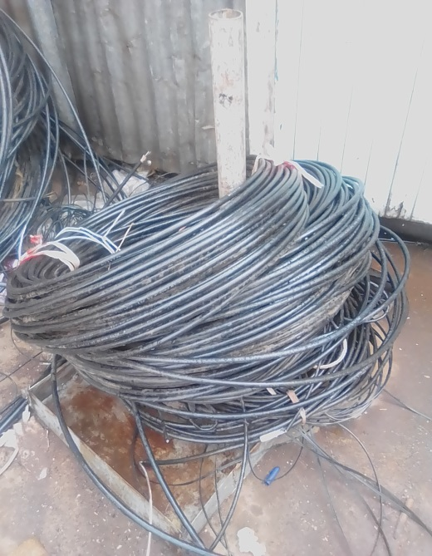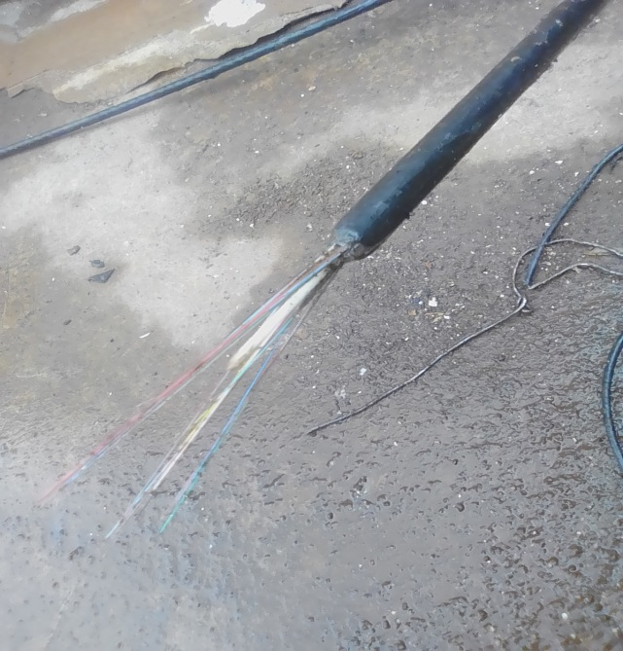

We also learned how to run a main cable from pole to pole.

I was also shown how to patch a patch cord in a connector.

The connector is shown in the next page figure 1.3

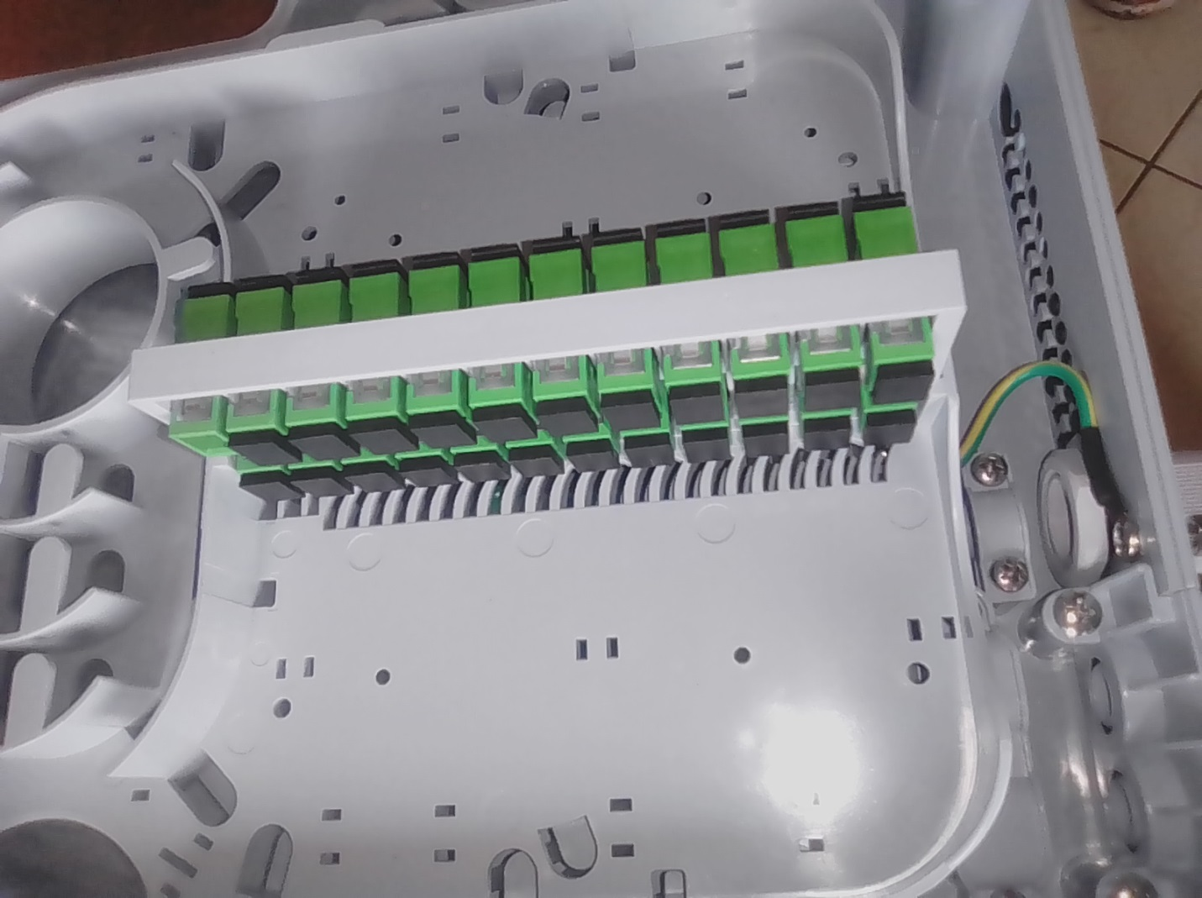

Figure 1.3 Connector in an odp

**Week 3 summary**

This week I gained lots of fiber optic knowledge this includes;

1. *Improving by in splicing*
2. *Running of drop cables*
3. *Also I improved using optical tools such as strippers, cleaver, laser etc.*

Also in this week I learned how to prepare optical closure in a pole which is (housing of fiber, cores and tubes)

The optical closure is as shown below.

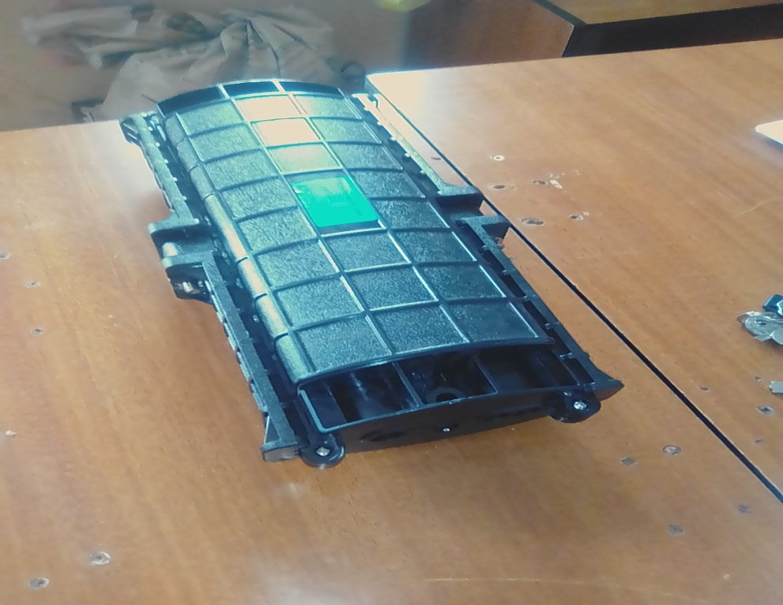

We also did installation of routers in clients home. I learned how to spice cores in a client’s home.

And also we did support (where I gained knowledge in support of fiber)

**Week 4 summary**

This week mostly we did support

Instances which requires support;

1. If there is a fiber cut
2. Fold of the cable or patch cord
3. And finally if the patch cord is covered with dust

I also learned how to use a fiber optic laser

Functions of the optical

* Used to identify core from a splitter or from a client’s home etc.

Laser is shown below figure 1.4

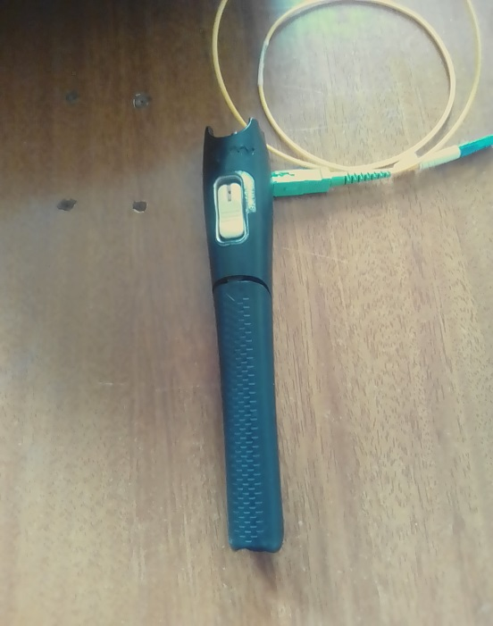

Figure 1.4 laser

**Week 5 summary report**

This being the second month I learned a lot and gained lots of knowledge

This week I was able to participate in fiber work include giving out opinions/ideas in the installation due to my cooperation and effort.

I also did few things in computers (*computer hardware*) include RAM installation and also doing service to a desktop.

We were also given lessons on safety in the field includes wearing overalls,reflectors etc.

We also learn how to activate signals from a splitter and also how to install a splitter

An example of a splitter is as shown below figure 1.5

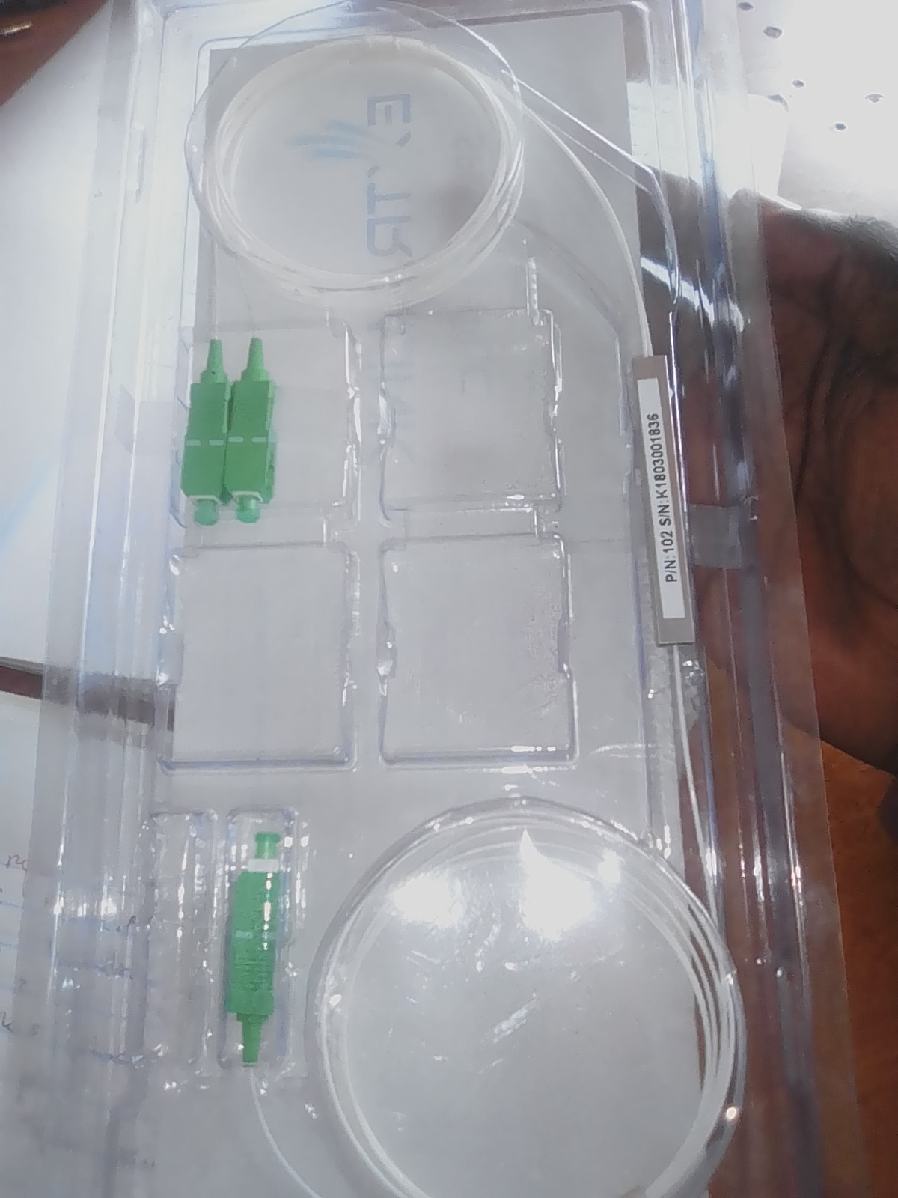

Figure 1.5 spl

**Week 6 summary report**

The week was fine and each task was completed on time, I improve a lot in fiber optics. This includes the following;

* + - Splicing
    - Running drop cables
    - Main cable
    - Cable preparation etc.

Challenge encounter in the week;

* + Some clients communicated in a rude manner, in places/times of marketing.
  + ‘Harsh weather’ conditions because in most cases our work was in the field.

We also did micro wave radio installation, and also support.

An example of a splicing machine includes below figure 1.6

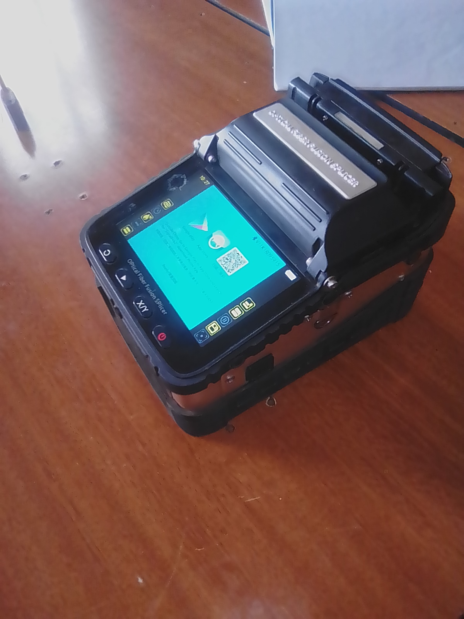

Figure 1.6 splicing machine

**Week 7 summary report**

This being the seventh week of my training attachment, I had learned a lot, I was able to do installation by myself, in a client’s home we did couple router installation.

Example of a router is shown in the figure 1.7

I also learned how to activate signals from an enclosure.

We also did support in the splitter or from the splitter, and finally we also run drop cable from the enclosure to client’s router

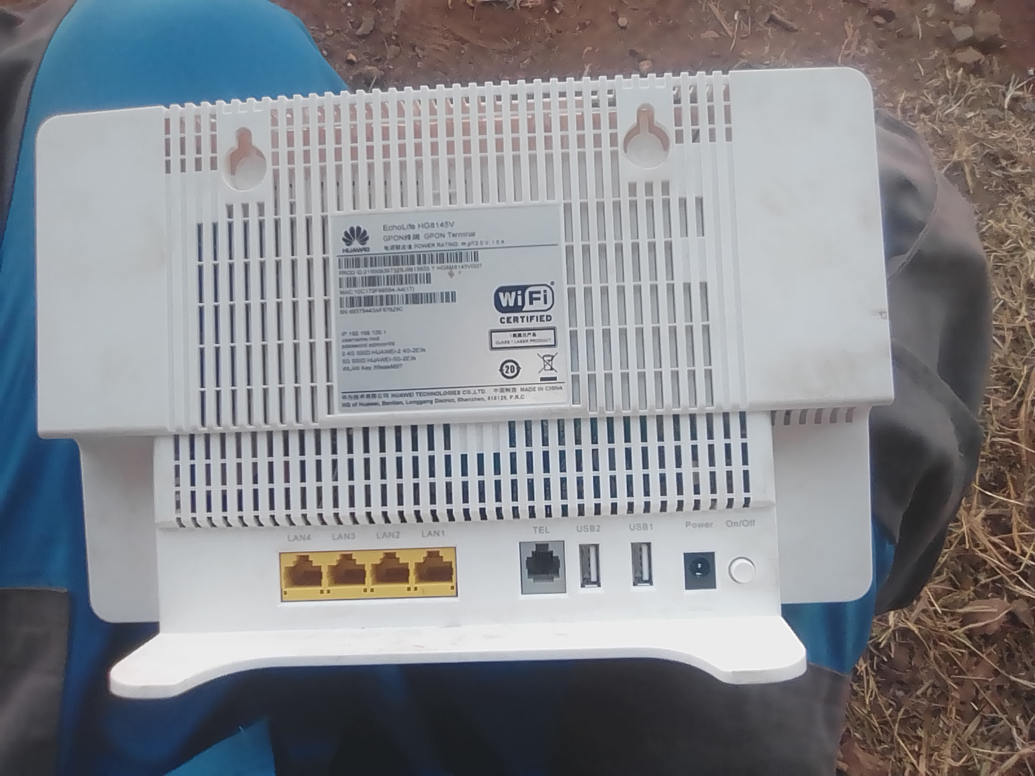

Figure 1.7 WI fi router

*Features of a router*

* *Lan ports 1-4*
* *Power ports*
* *Telephone port*
* *Optical port*
* *Power button*
* *USB port*

**Week 8 summary report**

In this week we learned how to install a splitter in an odp, where you activate a backbone and splice it with one of the patch cord from a splitter.

Experience/skills gained;

1. Supervised skills
2. Interpersonal skills
3. Process of installation

* router installation
* running drop cables
* activating signal
* fiber routing in an odp

an example of odp figure 1.8

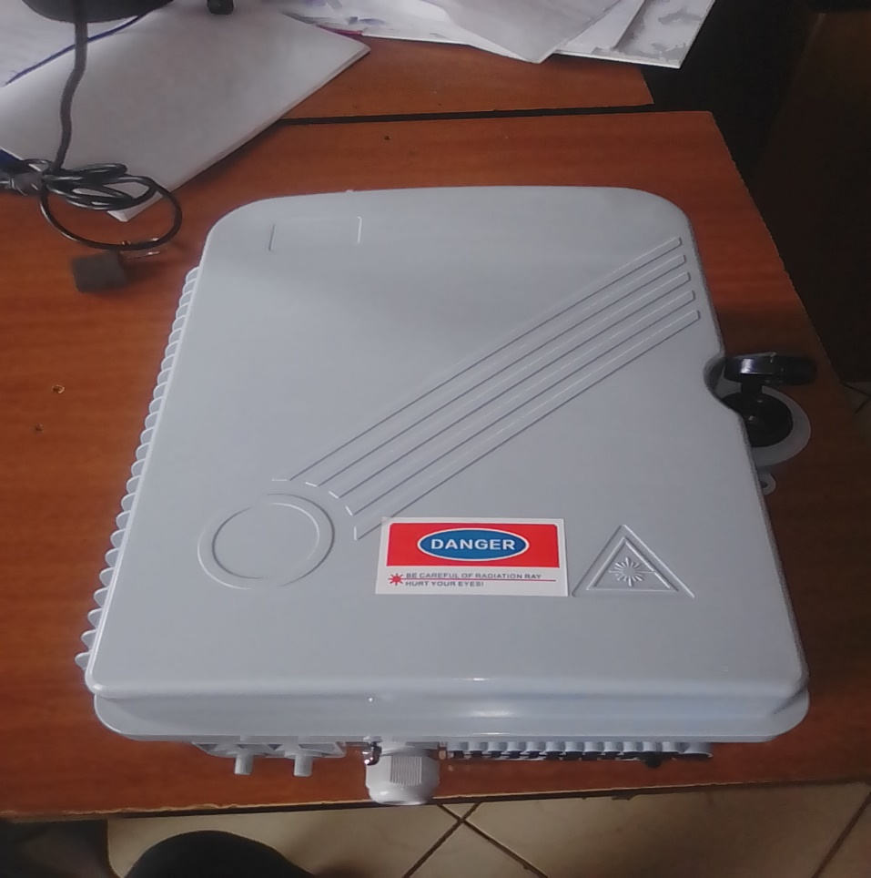

Figure 1.8 odp

**Week 9 summary report**

In this week work was organized on time, and all tickets were planned well and completed at the right time. I learned or I acquire interpersonal skills and also I learned how to operate an OTDR

*Functions of an OTDR*

* It measure losses
* Length of the cable
* Fiber signal strength

OTDR does its function with the help of a patch cord or a pick tail.

An example of an OTDR includes in figure 1.9

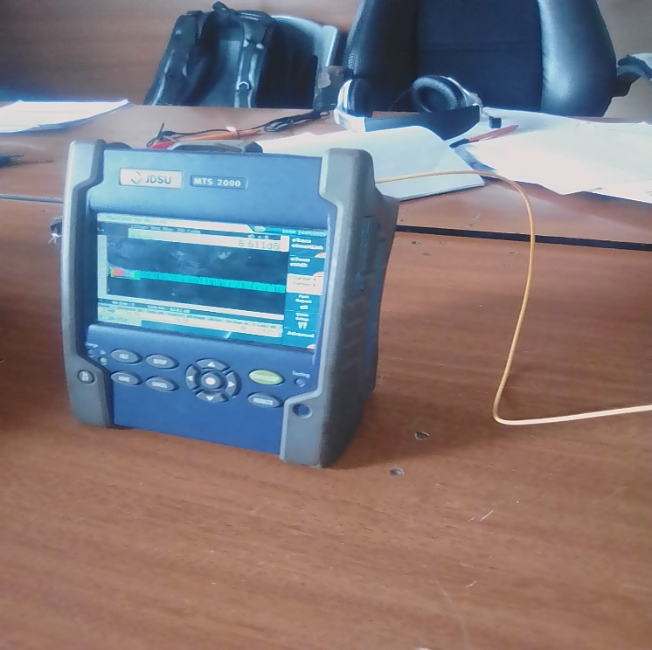

FIGURE 1.9 otdr with a pick tail

Optical domain time reflect meter (otdr) can measure its distance in meter and also in kilometers.

**Week 10 summary report**

This is the tenth week of my attachment training exercise, I acquired a lot of working skills and also behaviors which includes; respecting your colleagues, being proactive, and also interacting with them.

I also gained some experience or improved my knowledge in splicing of core from a splitter and also in and enclosure or an odp.

I also learned how to prepare cables in the enclosure and also, how to prepare a splitter in an enclosure…where we call it end point.

The figure 1.10 shows the end point

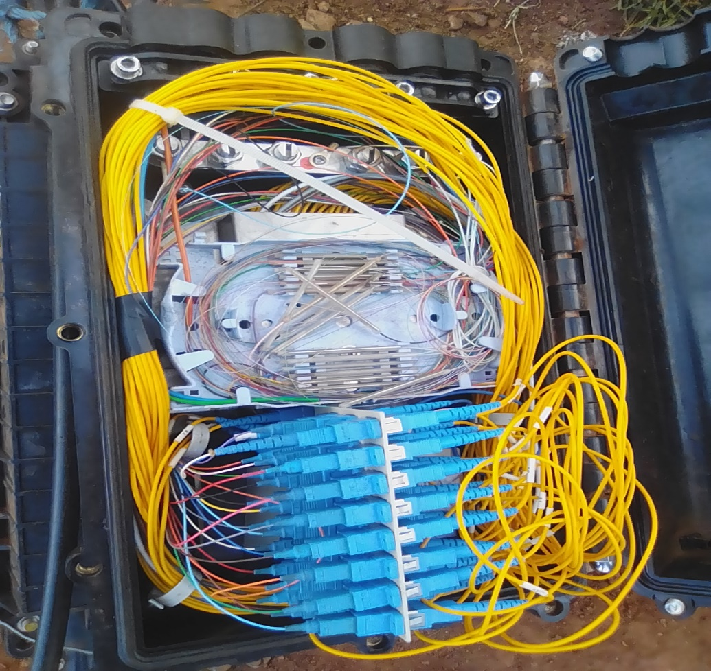

Figure 1.10 end point

**Week 11 summary report**

This being the last second week of attachment training period, I would say that I have learn a lot and gained lots of experience, in;

* Splicing
* Inspection of goods
* Working environment
* Managing a cable, running drop cables
* Being proactive
* Work arrangement
* Supervised skills
* Interpersonal skills etc.

In this week we did installation in the clients home where we,

* Did splicing of cores
* Running of drop cables
* Activation of a splitter
* And finally installation of a router

This week I improved a lot of field work and also office work, I also had challenges but I thank the Almighty for the strength that He have given to me.

**Week 12 summary report**

I thank firstly God for His divine protection, because despite of all I faced I came through or I made it safe, throughout my attachment exercise of a period of 3months.

Secondly I thank the company Easy broadband for the lesson and knowledge that I gained due to my attachment exercise, I also thank Emmanuel Ireri who was our supervisor, for helping us understand the field of networking in the organization.

This being the final week of my attachment I would say that I was well, equipped with the fiber knowledge of splicing and installation.

I also learned about the optical line terminal thereafter abbreviated as ‘OLT’

An example of an olt includes below and also where it is placed figure 2.0 and figure 2.1

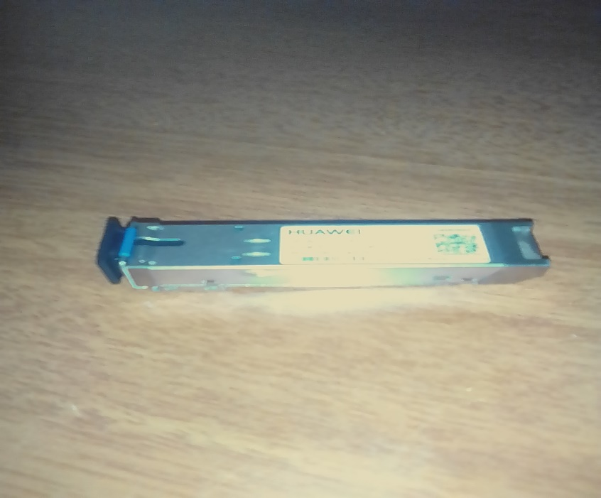

Figure 2.0 OLT

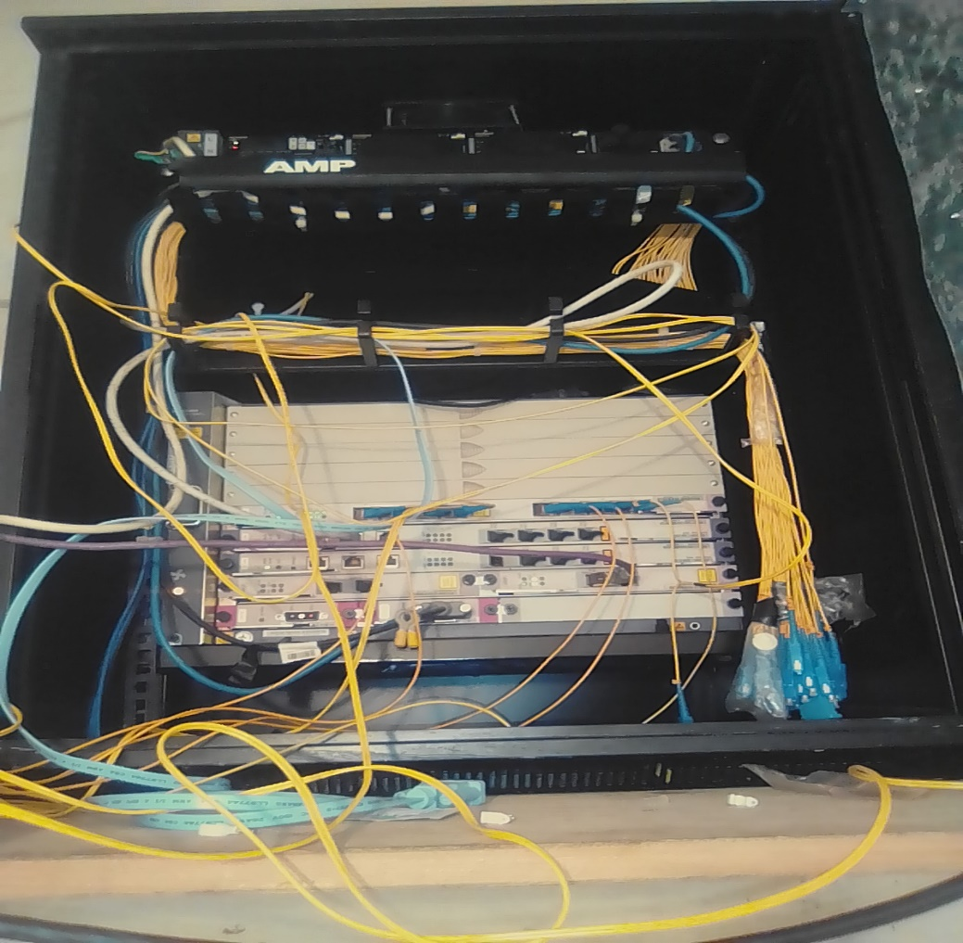

FIGURE 2.1

* This is where the OLT is installed.
* This is also where the backbone is being activated.